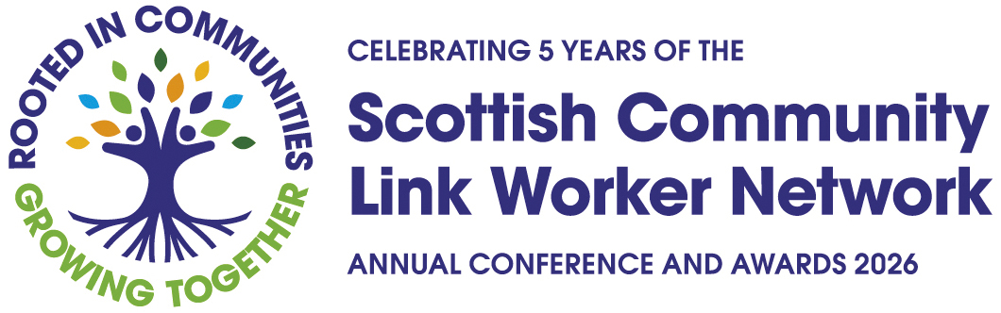

Celebrating Excellence in Community Link Working Across Scotland!

The SCLWN will host its fourth annual conference in Scotland on the 22nd September at Dynamic Earth in Edinburgh. As part of the event, we are excited to announce 3 awards to celebrate the outstanding contributions of Scotland’s primary care Community Link Workers (CLWs).

Scotland’s CLWs provide an essential role that supports people with complex health and social issues; they are vital to closing the health inequalities gap in Scotland and supporting a preventative-led approach to health. Our awards are an opportunity to recognise and celebrate their work.

We would like to invite community link worker teams from across Scotland to enter our 2026 awards. Prior to the conference, our judging panel will select a small number of finalists to be shortlisted for each category. One winner will be selected for each category and announced on the day!

Award Categories and Criteria

The three entry categories are:

Community Link Worker Team of the Year
We want to hear from teams who have gone above and beyond for their clients and communities to enable healthy outcomes for people in Scotland. We want to hear from new teams as well as more established teams about how you have worked effectively within your practices and the local community to make a difference.

Please outline:

- What you did and what made the last year particularly special?
- Include facts and figures on how you achieved your success.
- Provide real life examples of the impact you have had, you might want to include case studies and testimonials.

Outstanding Scottish Community Link Worker of the Year
We want to hear about individual community link workers who have truly embodied the role to create fairer health for their clients; who have made a real difference to their lives as well as to their practices and the local community. You can self-nominate or nominate a colleague whose dedication and impact deserve to be recognised.

Please outline:

- What made this year special for you (if self-nominating) or the CLW you are nominating?
- Provide facts and figures about how their work has made a positive difference.
- Tell us about the impact they have had on their clients, colleagues, community and primary care.
- Show us the difference they have made – you may want to use case studies and testimonials.

Community Link Worker - Partnership of the Year
We want to hear about an individual or a team who has worked innovatively in partnership with other local or national groups to improve health outcomes for their local communities. Your partnership might have involved teaming up with a local greenspace charity to set up walking groups to tackle social isolation or working with a literacy charity to provide books to low-income families. We want to hear about what you did, how you did it and the difference it has made!

Please outline:

- Who was involved in the partnership, provide information on who you worked with and their role.
- What you were trying to achieve through the partnership.
- How did you adapt and work together to achieve your aims?
- Facts and figures to illustrate your success and showcase outcomes.
- Any examples to demonstrate the difference the partnership has made, including case studies and testimonials.

Guidance and key information for entries

Please complete this form and please submit your entry by 5pm on Monday 8th June 2026.

What should be included?
Please include all relevant information, particularly in relation to the work you are doing to reduce health inequalities. Please try and evidence as much as you can the impact and difference the work has made. Highlight key achievements or milestones. You can include quotes, case studies and images along with your written entry.

Permissions
Please ensure you have permission from all named organisations and individuals. Please also ensure you have permission for images, data and other content.

Timeline and deadlines
The deadline for entries is 5pm on Monday 8th June 2026. We will be in touch shortly after the closing date to advise if you have been shortlisted. The winners will be announced and presented with their awards on 22nd September at the SCLWN Annual Conference at Dynamic Earth, Edinburgh.

Need help or have questions?
Please contact cecily.may@vhscotland.org.uk or roisin.hurst@vhscotland.org.uk

