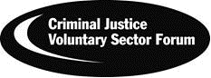
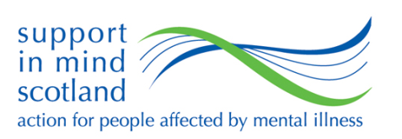
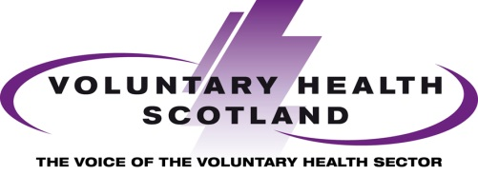

Unequal lives, unjust deaths

Health inequalities and vulnerable adults
21 August 2014

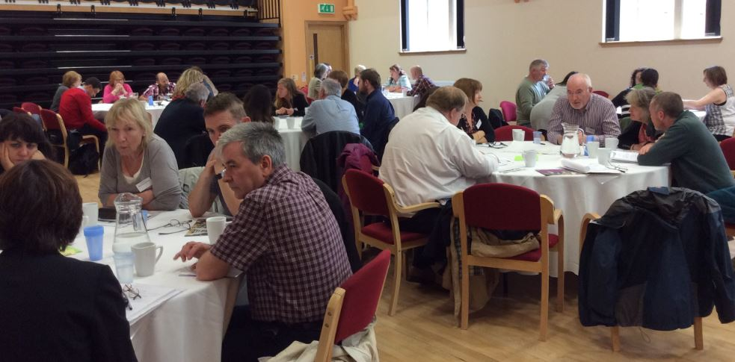

Contents

Unequal Lives, Unjust Deaths Programme 2
Vulnerable Adults – 21 August 2014 3
Presentations 4
Group Discussions 6
Contact 10

Unequal Lives, Unjust Deaths Programme
Scotland’s health is improving. However, the gap in health outcomes between the most and least advantaged groups in society is widening. People who are part of a lower occupational class or have a lower level of income, with a lower level of education, are more likely to have greater health problems, be sicker for longer and die at a younger age than more advantaged groups.
These inequalities are apparent from the earliest stage in life, and their impact can build throughout a person’s life. However, the good news is that they are not inevitable; they can be prevented, reduced and reversed.
These inequalities are caused by a complex combination of factors, which cannot be solved by health agencies alone. A number of factors, such as housing, education and employment all impact on people’s life chances and help shape individual opportunities and responses. All agencies across all sectors need to work together to eliminate a social injustice that is unacceptable in 21st century Scotland.
One goal. Many Sectors. Unlimited potential
In May 2014, Voluntary Health Scotland launched a programme of events to examine these inequalities, and their impact on people’s health, across the life course:
- Children and the early years
- Transitions from youth to adulthood
- Vulnerable adults
- Later Life
Each event will support voluntary health organisations gain a better understanding of health inequalities, to share learning and experience about the interventions that make a difference, and to encourage and support collaboration and partnership between public and voluntary sectors.

Vulnerable Adults – 21 August 2014
Voluntary Health Scotland, the Criminal Justice Voluntary Sector Forum and Support in Mind Scotland jointly delivered the third seminar in this series of events, to consider health inequalities and vulnerable adults.
The event focused on the relationship between social exclusion – through custodial sentences, poverty or homelessness – and poor mental health, long term conditions, disability and shorter life expectancy. It also looked at the third sector contribution to preventing, reducing and undoing these health inequalities.
The Adult Support and Protection (Scotland) Act 2007 defines vulnerable adults as people, over the age of 18, who may be at risk of harm or neglect and who may not be able to protect themselves. Specific vulnerable groups may include people who have learning difficulties, or physical or mental disabilities. There is legislation in place to ensure people with certain characteristics are protected, for example though Equalities legislation. But of course, in the context of inequalities, this can affect anyone. The most deprived and disadvantaged in society may or may not be included within protective legislation or protected groupings. And they may not only be characterized by one condition or circumstance – many parts of their lives might be contributing factors.
Tackling health inequalities needs to focus on these people and the multiple social, economic, political and environmental challenges that affect their lives. These may be very small numbers of the whole population, but they represent a very high risk and its where our focus needs to be if we want to live in an equal and just society.
Remaining cognizant of the complex and multi-dimensional nature of inequalities among vulnerable adults, the seminar also discussed the need for all sectors to work together to address health inequalities. There is a real need to move away from doing things to people, to doing things with people - connecting people to their communities, developing social capital and reducing social exclusion.
We, the voluntary and statutory sectors, have the power and skills to address the causes of inequalities and, working together, we can repair the damage. With the help of keynote presentations, we set out to explore these concepts in relation to some high risk groups. Through table discussions, we identified how and why the voluntary sector is a key partner in helping public agencies prevent, reduce and reverse the health inequalities facing people.

Presentations

The seminar received presentations from the following speakers:

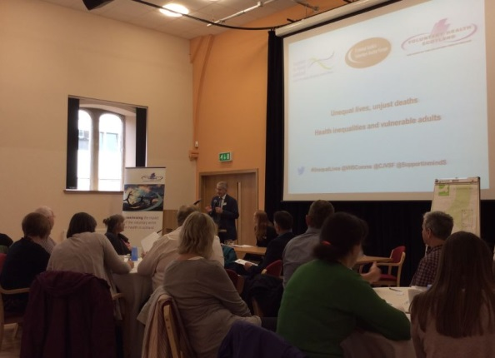
Andrew Fraser, NHS Health Scotland – Andrew spoke about the evidence base for tackling health inequalities in vulnerable adults. He specifically examined what is meant by the term vulnerable adults, the multiple challenges people face in terms of mental, physical, social dimensions to health and what is the most effective in tackling these inequalities.

Tony Rednall, Creating Health Team, Scottish Government – Tony spoke about current and emerging policy and legislation surrounding health inequalities. This included examination of the Ministerial Task Force on Health inequalities, priority areas for action and the role of the NHS and other organisations in tackling health inequalities.
Frances Simpson, Support in Mind – Looking at the links between physical and mental health and the health inequalities attached to serious mental illness, Frances spoke about inequality in society and the need to ensure that broad population-wide measures do not inadvertently marginalise the worst off. She also examined the need for an integrated physical and mental healthcare model, and the need for a cultural shift to accompany that.
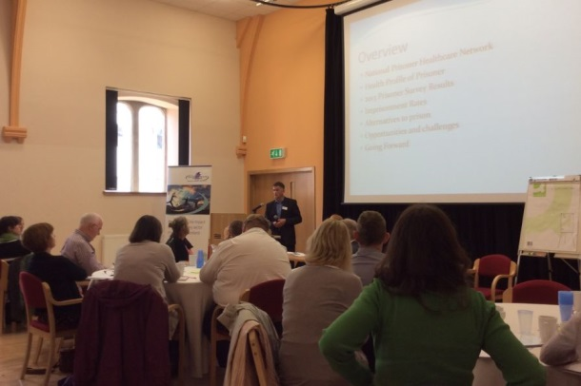
John Porter, National Prisoner Healthcare Network – John spoke about the challenges and opportunities in relation to health services in prison. He looked at the health profile of prisoners and the wide range of health issues that are often associated with their offending behaviour. He also detailed the work of the National Prisoner Healthcare Network and examined the results of the 2013 Prisoner Survey.
Presentations from Andrew Fraser, Tony Rednall and John Porter are available to view on the Voluntary Health Scotland website –http://www.vhscotland.org.uk/unequal-lives-vulnerable-adults/
Main themes
The day highlighted a really complex picture in relation to tackling health inequalities among vulnerable groups. However, a number of themes for action emerged.
Tackling inequality is about more than just health, health inequalities manifest as a result of wider inequalities in society. These inequalities are caused by a complex combination of social, economic, political and environmental factors; these all impact on people’s life chances and help shape individual opportunities and responses. There is a real need to address inequalities in general, along with their underlying causes of inequalities – money, power and resources – through upstream intervention.
However, this seminar has also reflected a real need to focus on the complex picture of the individual, the multiple factors that shape their lives on a basic level, and the effect this has on people's health. We need more integrated care and support across and between sectors and we need to be able to create the conditions to enable and empower people to be able to take care of their own health and wellbeing.
Going forward, we need a real focus on collaboration and partnerships - including ensuring that service users, carers and third sector organisations can engage with health and social care work and the integration of services. But we also need to ensure that people have the capacity to be able to do so and that begins with increasing social capital and working with the most vulnerable and marginalised people in society.

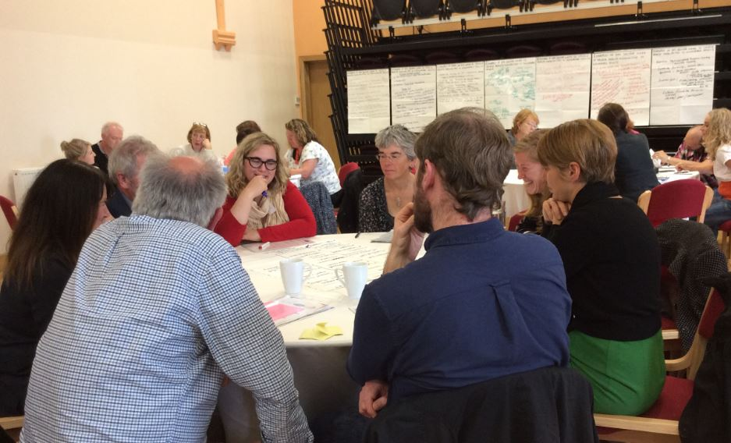

Group Discussions

Following the presentations, the session split into smaller discussion groups to discuss third sector work that reduces health inequalities for vulnerable groups, as well as challenges and opportunities and further support required to reduce health inequalities.
Third Sector work
What work is currently being done by the third sector to contribute to reduce health inequalities for vulnerable adults?
The discussion highlighted a wide variety of work in the third sector including providing basic human needs, developing community capacity and improving access to and engagement with services.
There was also significant focus on the delivery of professional and person-centred care and learning exchange and working between and across sectors.

Figure 1: Types of third sector work discussed during the session
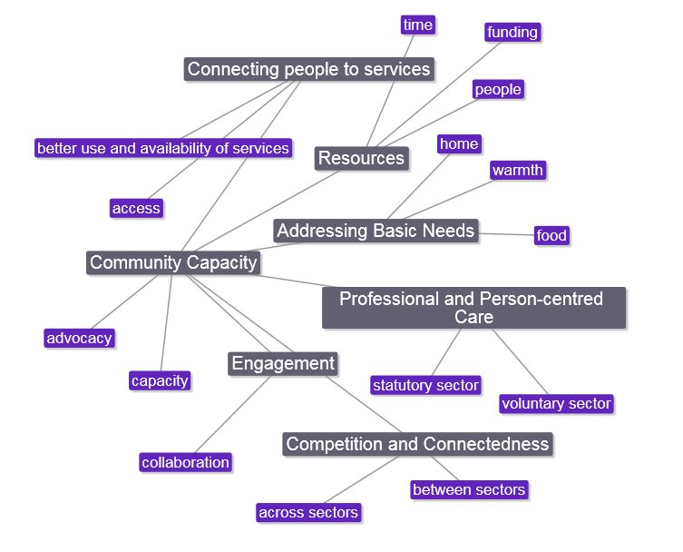
In particular we heard excellent examples of organisations and projects working directly with vulnerable groups to reduce health inequalities. Examples discussed on the day included:
Bridgend Growing Communities - Bridgend Growing Communities is an organic community garden and allotment project based in Edinburgh that aims to give participants a sense of personal effectiveness and wellbeing. It promotes employability, health and social development opportunities for people from a wide variety of backgrounds.
Carr Gomm Community Compass – A link programme to enable social prescribing in the Craigmillar area of Edinburgh. The 2 year project provides assistance to staff in Craigmillar Medical Centre to identify local support in their area and match that support to the needs of specific patients to help people improve their health, change their lifestyle, and deal with debt and other issues.
Circle - a Scottish charity working at the heart of deprived communities across central Scotland. They aim to support the most disadvantaged and difficult-to-engage children and families to improve their lives and promote their healthy potential and development.
Citizens Advice Scotland and CAPS Advocacy Agency – working in partnership to support vulnerable people with mental health issues to access and sustain health related benefits. They help people to set their own agenda, make their wishes known and to have a say in how they live and what services they use.
People First (Scotland) - an independent self-advocacy organisation in Scotland run by and for people with learning difficulties, providing intensive support for people and families, counselling, campaigning and policy work to promote rights.
The Serenity Café - a social hub for people in recovery, led by people in recovery. First developed around the idea of a social enterprise cafe which could cater for the social needs of people in recovery trying to avoid the pressures to drink and use drugs found in many adult social situations in Scotland. However, the service soon grew to develop the recovery community and offer a wider range of opportunities for people in recovery to support each other and develop, personally and socially, as they adjust to life without alcohol or drugs.
West Lothian Financial Inclusion Network – a charity that aims to ensure that all West Lothian residents are aware of their financial choices and promotes access to financial advice, financial products and other services, particularly for the most excluded social groups.

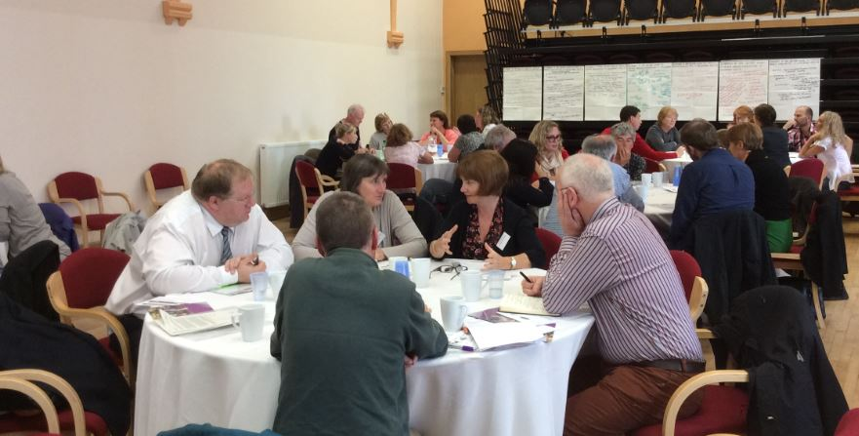
Challenges
We asked delegates what the main challenges are that the third sector faces when addressing health inequalities amongst vulnerable adults. Responses included:
- Funding, capacity and stability of services, coupled with the difficulties balancing service delivery and taking advantage of other opportunities/campaign/having a voice in policy development.
- Working with challenging communities and ‘hard to reach’ areas.
- A lack of suitable support can mean that many individuals return to their initial circumstances and then can repeatedly present at services with the same issues.
- A lack of preventative support – often services respond to a distress or crisis, there needs to be a bigger focus on help in early stages.
- Producing robust measurement and evaluation of projects to maintain a strong body of evidence on third sector work to tackle health inequalities.
- Recognition of the third sector as professional organisations with professionally qualified and trained staff.
- Stigma attached to certain conditions or people – there is a real need to challenge attitudes.
- Engagement and access – there are substantial differences between accessing different types of services, including criteria, length and support available. Services also assume people have the capacity to attend.
Opportunities
Delegates identified the following opportunities to further tackle health inequalities amongst vulnerable adults:
- Placing an emphasis on engagement and access with local communities – developing more trust within communities and understanding of local needs and developing both community and group work – making sure that there is emphasis on community engagement and that work is embedded in communities.
- Creativity and a focus on prevention
- There seems to be willingness for the statutory sector to work in partnership with the third sector.
- The third sector can add value to the work done by the statutory sector e.g. by offering services out-of-hours, responding to both opportunities and the need for support quickly, and being ideally placed to provide person-centred and individualised support.
- Ensuring people have a voice in policy development.
- Flexibility and learning to enable early intervention and prevention.
What further support do we need to create our vision?
Delegates identified a range of further support needs, including:
- There needs to be holistic support to be able to respond to complex issues – which ensures that services are not fragmented and people allowed to slip through the net. There also needs to be a significant focus on how agencies and organisations respond to distress – this is crucial to develop relationships and ongoing support.
- Sustainable project funding and long-term plans. Addressing health inequalities requires time and investment; Health inequalities will not be solved by short term projects. We also need to build the evidence base to show the long term effects of voluntary sector work.
- Meaningful engagement and collaborative work with the statutory sector – particularly to support culture change and myth-busting about the voluntary sector. This goes alongside greater awareness of the voluntary sector, less tokenism and more involvement in community planning.
- There needs to be co-ordination to keep health inequalities at the forefront of policy thinking and bringing services together under a common cause.

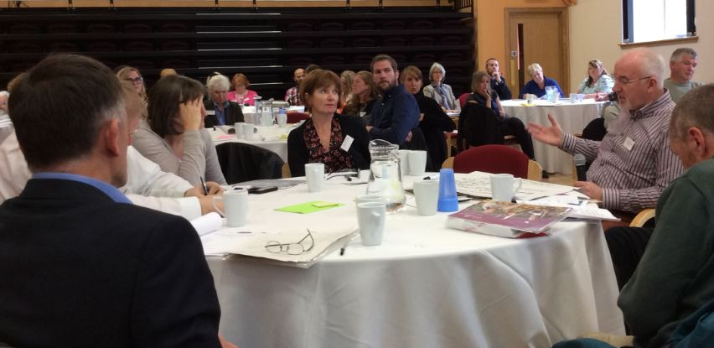

Contacts
Voluntary Health Scotland
If you would like further information on the programme of events or the work of Voluntary Health Scotland to prevent, reduce and undo health inequalities, contact Susan Lowes, Policy and Engagement Officer susan.lowes@vhscotland.org.uk
Voluntary Health Scotland, Mansfield Traquair Centre, 15 Mansfield Place, Edinburgh, EH3 6BB. Tel: 0131 474 6189. www.vhscotland.org.uk mail@vhscotland.org.uk VHS is supported by NHS Health Scotland and the Scottish Government. VHS is a company registered by guarantee. Registered in Scotland No. 267315 Charity No SCO3548
Criminal Justice Voluntary Sector Forum
The Criminal Justice Voluntary Sector Forum (CJVSF) is a collaboration of voluntary sector organisations working in criminal justice in Scotland. We help and support voluntary sector organisations to:
- Continuously improve their own criminal justice services through collaboration and sharing of good practice
- Understand, navigate and influence the complex and changing environment in which they operate
- Promote broader awareness of the activities, value and impact of voluntary sector services within criminal justice.
CJVSF is hosted by CCPS and funded by The Robertson trust and The Monument Trust. CCPS is a company limited by guarantee registered in Scotland No. 279913, registered with the Office of the Scottish Charity Regulator as Charity No.SCO29199.
For further information contact Laura Mulcahy, Development Coordinator - Laura.Mulcahy@ccpscotland.org. Tel: 0131 475 2676. Address: Norton Park, 57 Albion Road, Edinburgh, EH7 5QY.
Support in Mind Scotland
Support in Mind Scotland works to improve the wellbeing and quality of life of people affected by serious mental illness. This includes those who are family members, carers and supporters. They support and empower all those affected by mental illness.
For further information contact info@supportinmindscotland.org.uk Tel: 0131 662 4359. Support in Mind Scotland is the operating name of the National Schizophrenia Fellowship (Scotland), a company limited by guarantee registered in Scotland SC088179. Registered Office: 1 Rutland Court, Edinburgh EH3 8EY. Charity Number SC 013649.

