Public Bodies (Joint Working) (Scotland) Bill (Stage Two) – Proposed Amendments
Supported by range of third sector organisations (see end of document)

This paper sets out the amendments that are being collectively sought by a large and diverse group of third sector organisations. These are intended to strengthen the legislation, particularly in terms of:
- supporting a human rights based approach
- co-production – ensuring service users and unpaid carers are central to planning and shaping integrated services
- ensuring the third sector has a strong role in joint strategic commissioning, integration and locality planning, and
- ensuring a focus on personal outcomes and on quality of provision

The amendments proposed have not been devised by legal experts and therefore may require additional work to finalise the precise drafting. The purpose of this paper is to make clear the intent behind the proposed amendments.

A Human Rights Based Approach

- All Scottish legislation must comply with human rights provisions. However, there is precedent in Scotland (in self-directed support and mental health legislation and dementia policy) for going beyond legal compliance and embedding human rights proactively as the underpinning framework to drive culture change, transformation and improvement in services and paving the way for a human rights based approach in strategic commissioning, workforce development and practice.
- Embedding a human rights based approach in the Public Bodies (Joint Working) (Scotland) Bill would reflect: the Christie agenda; the drive for co-production; a focus on the outcomes that matter to people using services and their families; and coherence with self-directed support. It also would provide a fair framework for strategic commissioning at a time of constrained resources (enabling outcomes/equality considerations to be given appropriate weighting against financial considerations).
- At a service/practice level examples such as ‘Care about Rights’ demonstrate the efficacy of a human rights based approach in supporting service users and staff, in particular enabling risk to be managed effectively as part of a personal outcomes approach.
- Including the term ‘independent living’ alongside ‘wellbeing’ is key to reflecting read-across to self-directed support. This would also help enshrine Scotland’s commitment to the United Nations Convention on the Rights of Persons with Disabilities in law, putting us at the forefront within the UK.
- A human rights based approach provides a much stronger basis (than one focused on ‘need’) from which to drive prevention and tackle health inequalities – where people have a right to the determinants of health this directs focus towards the underlying factors that determine health outcomes. This is particularly important in the context of policy and resource challenges, including welfare reform.
- A significant additional driver for a human rights based approach to health and social care will come with publication of the first Scottish National Action Plan for Human Rights (SNAP) on 10th December.
Purpose | Draft amendment or provision in guidance
Introduce overarching human rights based principles at front of the Bill that apply to all its provisions  Principles reflect:  - Human rights  - Independent living and read-across to self-directed support  - Focus on outcomes that matter to people using services  - Needs of unpaid carers  - Quality of services  - Use of evidence to inform services/ practice | Before section 1, insert:  <Principles of integration  The principles of integration are –  (a) that the main purpose of services which must or may be provided in pursuance of functions which must or may be delegated under an integration plan is to improve access to independent living for persons who require those services and the wellbeing of persons who require those services and unpaid carers,  (b) in so far as consistent with the main purpose, these services should be provided in a way which, so far as possible—  (i) is integrated from the point of view of service users and unpaid carers,  (ii) promotes the independence of service users and respects the right of service users to  participate in the life of the community,  (iii) respects the right to dignity of service users and unpaid carers,  - protects and enhances the safety and welfare of service users and unpaid carers,  - enables service users to exercise choice and control and participate in decisions regarding their need for services and the provision of those services to them,  - takes account of the particular needs, aspirations, abilities, characteristics and circumstances of service users, including the particular needs of service users in different parts of the area in which the service is being provided,  - best anticipates the potential needs of service users and unpaid carers and seeks to prevent them arising,  - is led locally through the engagement of service users, unpaid carers, the local community and local professionals from across relevant sectors,  - is based on recognised guidance and adherence to established quality standards and promotes continuous improvement in the standards and quality of care, and  - makes the best use of the available facilities, people, evidence and other resources, appreciating the value of community and family provision but not placing undue pressure on informal support.  - provides unpaid carers with the resources they require to enable them to continue their caring role and have a life outside of caring.>  -------------------------------------------------------  For the purposes of the above ‘independent living’ is defined under Article 19 (‘Living independently and being included in the community’) of the United Nations Convention on the Rights of Persons with Disabilities. Guidance should also refer to the definition of independent living in the statutory guidance that will accompany the Social Care (Self-directed Support) (Scotland) Act 2013 (the draft of which includes a ‘statement of intent’ recognising that ‘care and support provision – and choice and control over that provision – plays a key role in helping to deliver independent living for disabled people’). It should also reference the ‘Shared Vision for Independent Living in Scotland’ agreed by Scottish Government, Scottish Independent Living Coalition, NHS Scotland and COSLA.  Wellbeing should be defined to reflect, not just a passive state of respect and comfort, but as the act of living an active participatory life. This includes having the rights and resources to participate meaningfully in life, including familial, social and civic activity. It must also reflect the wide range of determinants that enable this in addition to personal resources, including economic, civic, social/familial, environmental and health factors.
Replace existing ‘planning principles’ and ‘delivery principles’ with reference to new overarching principles proposed above | In section 3, page 3, line 5, leave out <integration planning principles (see section 4)> and insert <principles of integration (see section 1)>  Leave out section 4  In section 24, page 10, line 34 , leave out <integration delivery principles (see section 25)> and insert <principles of integration (see section 1)>  Leave out section 25  In section 31, page 13, line 30, leave out <integration delivery principles (see section 25)> and insert <principles of integration (see section 1)>
Embedding a human rights based approach in guidance, implementation and practice | Point for secondary legislation/guidance:  In addition to the human rights based principles on the face of the legislation, guidance must also strongly and explicitly reflect a human rights based approach to health and social care, including in relation to strategic commissioning, service delivery, health and wellbeing national outcomes and workforce development.

Preparation of Integration Plans – co-production, accountability, quality and complaints

Purpose | Draft amendment or provision in guidance
Embedding into integration plans:  - accountability/ monitoring of resource use  - quality, improvement and safety of services  - single point of entry into complaints processes, whether these are in relation to health or social care  - co-production with people who use services, unpaid carers and third sector  - community capacity building strategies to be developed to ensure that the local community is supported to co-produce support and services | In section 1, page 1, line 22, at end insert—  <( ) arrangements for monitoring the use of resources in respect of  delegated functions, including payments made under (3)(d),  ( ) arrangements for monitoring and improving the quality, safety and  standards of services in respect of all functions under (3)(b) and (c),  ( ) arrangements for single point of entry to the complaints system for services in respect of all  functions under (3)(b) and (c),  ( ) arrangements for co-production in the planning and delivery of all functions under (3)(b) and (c),  with—  - service users,  - unpaid carers,  - the third sector,  - relevant employees of the local authority,  - relevant employees of the Health Board,  - commercial and non-commercial providers of health care,  - commercial and non-commercial providers of social care,  - such other persons as the local authority and the Health Board think fit,  ( ) arrangements for development of a community capacity building strategy to support co-production with service users, unpaid carers and the third sector in respect of all functions under (3)(b) and (c),>

Co-production

- Page One of the Policy Memorandum accompanying the Bill quotes the Christie Commission Report in asserting that ‘…effective services must be designed with and for people and communities – not delivered ‘top-down’ for administrative convenience.’ It later (para 20) reinforces the principles of co-production as ‘underpinning the Government’s vision for mutual and person-centred public services, which encourage and utilise the talents, capacities and potential of all of Scotland’s people and communities in designing and delivering health and social services’.
- Despite the language of co-production in the Policy Memorandum the legislation is weak on ensuring this happens, referring instead to ‘consultation’ throughout. This must be strengthened so that people affected by the plans have a direct role in shaping them, a point reinforced by the Audit Scotland Social Care Commissioning Report (2012).
- If health and social care integration is a key plank in driving real change in public services, to enable them to respond to economic and demographic challenges, then the processes by which health and social care is commissioned, designed and delivered must be based on co-production. There is a growing bank of evidence that this:
  - produces better outcomes;
  - maximises the contribution of individuals, communities and the third sector alongside statutory services;
  - helps drive preventative approaches, and;
  - enables solutions to be found that are sustainable in the face of economic constraints (by making best use of financial and statutory and non-financial and non-statutory resources and preventing waste associated with poor commissioning processes).
- Evidence, learning, knowledge exchange and practical support for co-production is developing significantly in Scotland.

Purpose | Draft amendment or provision in guidance
In relation to consultation on Health and Social Care National Outcomes ensure inclusion of third sector organisations that may not be regarded as ‘providers’ but who form an essential part of the health and social care landscape e.g. peer support groups | In section 5, subsection (4) insert –  <(k) Other organisations contributing to health and wellbeing>
Introducing co-production in preparation of integration plans | In section 6, remove existing subsection (2) and replace with –  <(2) Before submitting the integration plan for approval under section 7, the local authority and the Health Board must jointly engage in a co-production process with –  - Service users  - Unpaid carers  - Third sector  - Such other persons or groups of persons appearing to the Scottish Ministers to have an interest as may be prescribed, and  - Such other persons as the local authority and the Health Board think fit
Reinforcing requirement for co-production in preparation of integration plans | Point for secondary legislation/guidance:  Section 7, subsection (3)(b) (Ministers’ refusal of integration plans) – guidance/secondary legislation will presumably specify what might form grounds for the integration plan to be refused and this should include insufficient engagement with the specified groups.
Ensuring the third sector, people who use services and unpaid carers are full, strategic partners and represented on all integration joint boards across Scotland | Points for secondary legislation/guidance:  Section 12, subsection (1)(a) (membership of integration joint boards) – guidance/secondary legislation should specify that the third sector (via the Third Sector Interface although they may delegate the role), people who use services and unpaid carers must be represented within the membership of the joint integration boards.  Section 16, subsection (1)(b) (membership of joint monitoring committees where ‘lead agency’ model is adopted) – guidance/secondary legislation should specify that the third sector, people who use services and unpaid carers must be represented within membership of joint monitoring committees.
Introducing co-production, rather than consultation in preparation of strategic plans | In sections 26 and 27, replace ‘consultation group’ with ‘co-production group’  Point for secondary legislation/guidance:  Section 26, subsection (2) (groups to be included in strategic plan consultation/co-production groups) – guidance/secondary legislation must specify that this includes the third sector, people who use services (including disabled people’s organisations and organisations representing people with long term conditions) and unpaid carers (including organisations representing carers).
Addressing barriers to participation frequently reported by third sector, people who use services and unpaid carers | Point for secondary legislation/guidance:  Section 26, subsection (4) (payment to members of strategic plan consultation groups) – guidance should require integration authorities to support effective involvement of the third sector, people who use services (including disabled people’s organisations and organisations representing people with long term conditions) and unpaid carers, including through reimbursing their expenses, providing information timeously before meetings/in alternative formats where appropriate, ensuring accessibility of meeting venues, replacement care and funds to access training for unpaid carers.
Inserting the requirement for formal sign-off by the third sector (as per RCOP Change Fund arrangements), rather than just having views taken into account.  Ensure the third sector is among those whose views must be taken into account in finalising the strategic plan | Section 27, subsection (6) (requirement on integration authorities to take account of views expressed by certain groups) replace –  (6) In finalising the strategic plan, the integration authority must take account of any views expressed by virtue of subsection (3)(c)  With –  (6) After finalising the strategic plan, the integration authority must submit it to the persons referred to in section (4) for approval  (7) If those persons do not approve the plan, the integration authority must modify the plan and submit it for approval under subsection (6)  Section 28, subsection (3) insert –  <(c) representative of the third sector>  Point for secondary legislation/guidance:  Section 27, subsection (5) (groups prescribed by Ministers ‘appearing to have an interest’ and whose views must be taken into account in finalising the strategic plan) – the groups specified by Ministers in secondary legislation must include the third sector (via the Third Sector Interface).
Ensure decisions about provision which affect key groups are shaped by those affected including key sector groups as both representative bodies and/or as a voice for users of services/carers. | Point for secondary legislation/guidance:  Section 30, subsection – significant decisions outside strategic plan, public involvement. Secondary legislation /guidance must include third sector and other relevant interests affected by such decisions.  Section 32, subsection (4) (groups to be consulted on decisions that significantly affect provision in a locality area) - guidance/secondary legislation must specify that this includes the third sector, people who use services and unpaid carers.
Introduce right to independent advocacy for people who use health and social care services and for unpaid carers | Insert new section –  < ( ) Every person who uses health and social care services shall have a right of access to independent advocacy; and accordingly it is the duty of each Health and Social Care Authority to secure the availability, to persons in its area, of independent advocacy services and to take appropriate steps to ensure that those persons have the opportunity of making use of those services.  ( ) Every unpaid carer shall have a right of access to independent advocacy; and accordingly it is the duty of each Health and Social Care Authority to secure the availability, to persons in its area, of independent advocacy services and to take appropriate steps to ensure that those persons have the opportunity of making use of those services.  ( )“Independent advocacy services” has the same meaning in subsection ( ) as it has in section 259(1) of the Mental Health (Care and Treatment) (Scotland) Act 2003 (asp 13).>

Effective implementation

- Strategic commissioning – if the quality of strategic commissioning processes is not adequate (for example the issues raised in the 2012 Audit Scotland report into commissioning social care) then the aspirations of health and social care integration will not be achieved. Provision must be made, either on the face of the Bill, in secondary legislation or in guidance that makes clear how the effectiveness of strategic commissioning (in terms of delivering improved personal outcomes for people using services) will be scrutinised and what action will be taken if these are found to be poor.

- A range of concerns exist of unintended consequences that may arise as a result of the Public Bodies (Joint Working) (Scotland) Bill. These include: regression in partnership working and cross sector relationships gained through the Reshaping Care for Older People Change Fund; domination of a medical model in health and social care (for example resulting in people being discharged from hospital if medically well, rather than taking account of their wider quality of life); and charges being progressively applied to support that is currently classified as ‘NHS Continuing Healthcare’ but which may be re-defined as social care. There should be a mechanism for Parliamentary review of implementation of the Bill, for example a Health and Sport Committee Inquiry and full chamber debate after the first year of enactment.

- People who use services and unpaid carers must be key partners in scrutiny of implementation of the Public Bodies (Joint Working) (Scotland) Bill, including in relation to strategic commissioning. Approaches need to be better developed to enabling people to be involved in a co-produced, constructive improvement process and the provisions of the Community Empowerment (Scotland) Bill may help to address this.

For more information please contact:
Shelley Gray, Director of Policy and Communication, Health and Social Care Alliance Scotland (the ALLIANCE), shelley.gray@alliance-scotland.org.uk / 0141 404 0231
November 2013

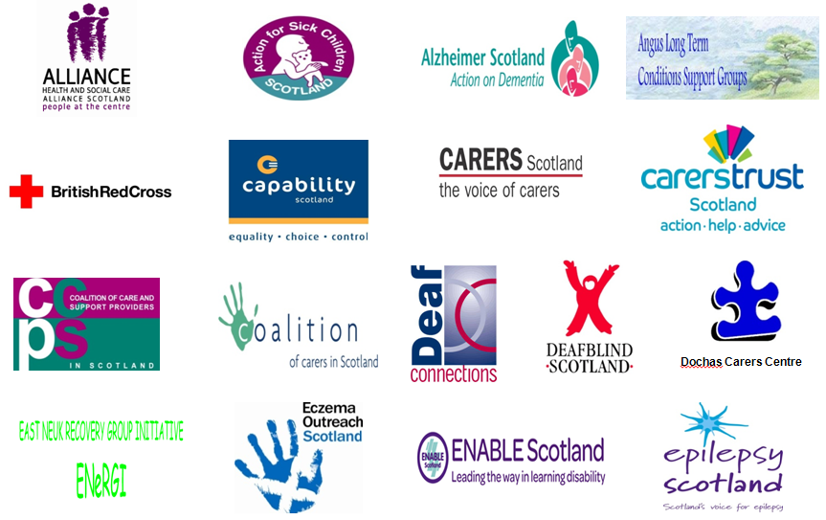
Supported by:

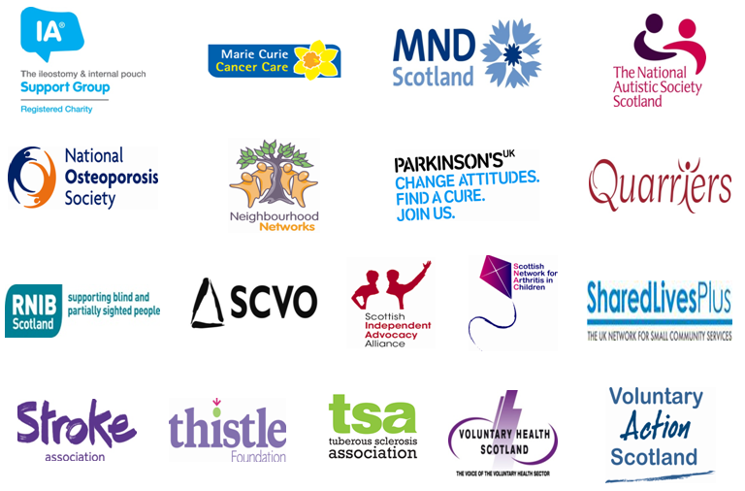

Examples include: Evidence cited in ‘Co-production of Health and Wellbeing in Scotland’ (Joint Improvement Team/Governance International 2013) and RCOP case studies The Business Case for People Powered Health, NESTA (April 2013) which suggests savings of around 7% of the commissioning budget through co-production in health Evaluation of Year 1 of Reducing Reoffending Change Fund which found co-production was one of the most valuable elements of the Public Social Partnerships (Scottish Government, 2013) Carnegie UK Trust’s Enabling State evidence review expected in 2013(led by Sir John Elvidge)

