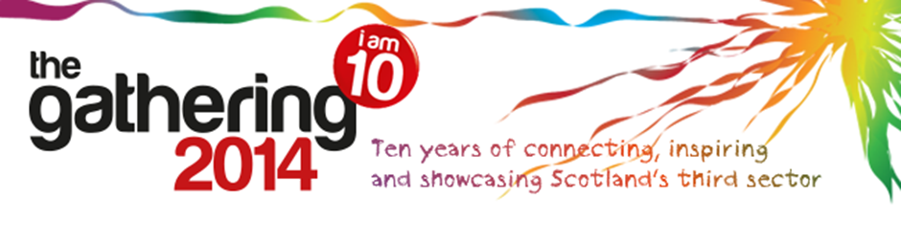

A FAIRER, HEALTHIER SCOTLAND: A WAY FORWARD TOGETHER

One goal. Many sectors. Unlimited potential.

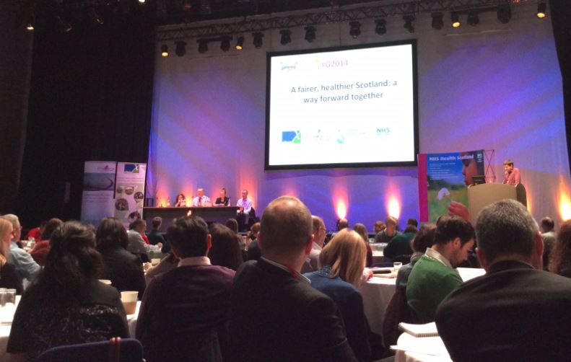
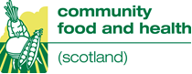
Contents

A Fairer, Healthier Scotland: A Way Forward Together 1
Introduction 3
Make a difference… 3
A way forward together 4
What does good practice look like? 5
Barriers 6
Key lessons 7
Themes from the panel discussion 8
The final word 9
Partnership 9

Introduction

Community Health Exchange (CHEX), Community Food and Health Scotland (CFHS) part of NHS Health Scotland, and Voluntary Health Scotland jointly delivered an event and hosted an exhibition stand at the 10th annual Gathering; a two day annual conference for third sector organisations across Scotland, convened by the Scottish Council for Voluntary Organisations (SCVO).

Across the two days, we met many passionate people from across the voluntary, private and public sectors, and were delighted with people’s commitment to tackle health inequalities.

Make a difference…
At the conference, we launched our make a difference… campaign to raise awareness of the work in the voluntary sector to tackle health inequalities. Visitors to the exhibition stand told us how they were working to address health inequalities and made pledges of the work they will undertake in the future.
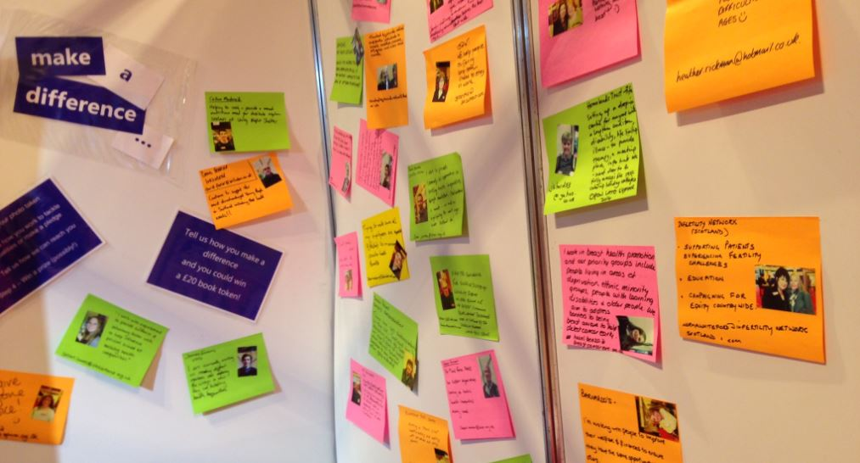
Here are some examples of what people had to say:
“We give everyone a voice! :)”

“I'm working with people to improve their welfare and finances to ensure they have the same opportunities as others.”

“Touched by Suicide Scotland supports individuals to break isolation, overcome stigma and widen social circle.”

“We are passionate about supporting mums, babies and families go break the cycle of health inequalities in some of Scotland's most deprived communities by giving information and support to empower them to give babies the best start in life.”

A way forward together
The joint event at the conference - A Fairer, Healthier Scotland: A Way Forward Together focused on the underlying causes of health inequalities, what we can do to best address these, and the recognition that way we organise our services and resources can make a difference, and an opportunity to examine collaborative approaches for preventing and tackling health inequalities across Scotland.
The conference received presentations from:
- Keynote address - Dr Linda De Caestecker, Director of Public Health, NHS Greater Glasgow and Clyde

- What works to reduce health inequalities? - Gerry McCartney, Head of Public Health Observatory, NHS Health Scotland

- Local geographic perspective from Healthy n Happy Community Development Trust, Cambuslang and Rutherglen - Brendan Rooney, Executive Director, Healthy n Happy

- Tackling health inequalities: a holistic approach or why prevention is better than cure - Maggie Kelly, Interim Policy Advisor, One Parent Families Scotland

Presentations from the event are now available to view online.

Following the presentations, the session split into smaller discussion groups to look at good practice in supporting collaborative work on health inequalities, barriers to this, and what key lessons to share.

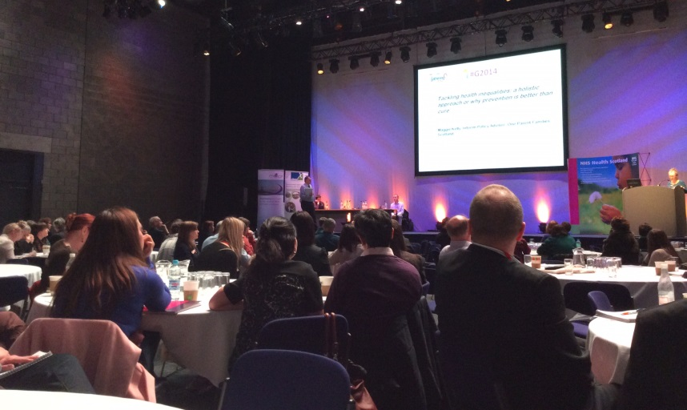

What does good practice look like?

A shared goal around improving health for the people of Scotland, sharing resources and ideas.

Recognition of what each partner can bring to the partnership and using those resources effectively. Breaking down silos and understanding, respecting and valuing different contributions, including inter-professional education and establishing effective co-ordination.

Community-led approaches and working with communities, including collaboration by and for people rather than agencies.

Relationships - developing good, sustainable relationships with partnership working at all levels.

A holistic view of tackling health inequalities - with a broader definition of health that takes into account social determinants, for example, housing, welfare and the labour market, training, education, personal development and transport.
Evidencing outcomes and need in addition to identifying need.

Being open, honest and positive, offering feedback to partners and communities.

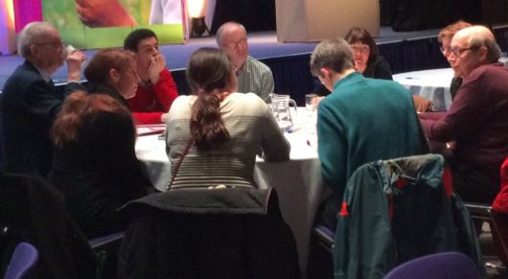

Barriers

Funding – consistency of staffing and contacts on both sides; fulfilling requirements obligations and demonstrating innovation to secure further funding; transparency around decision-making, and opportunities to influence funding guidelines; tensions around funders also being partners with a third sector organisations; and investments in third sector partnerships.
Relationships with partners – multiple partners and working with different cultures; language and performance indicators; third sector partners recognised and treated as an equal partner; lack of communication across sectors; system, hierarchy and institutional barriers; and how to address statutory sector outcomes through community-led approaches.
The third sector – competition between organisations; a broad range of perspectives and priorities; and ensuring all voices are heard.
Evidence and evaluation – collecting evidence of effectiveness can be challenging; numerous different types of evidence required; and presenting information in multiple formats to fit the needs of different statutory sector partners.
Joint commissioning and integrated budgets – ensuring preventative work is adequately resourced; and that the third sector has an equal stake in the commissioning process.

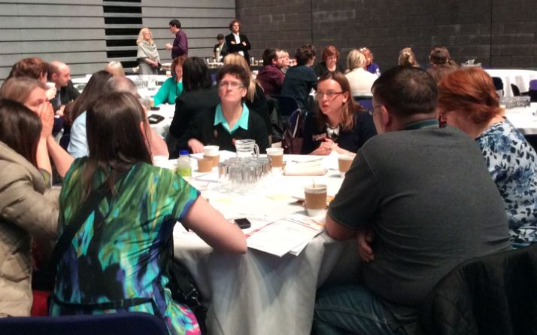

Key lessons

Human rights approaches should embedded in every collaboration.
Getting the right resources and providing evidence to inform that.
Connecting constructively with partner organisations, including joint responsibility and communication between all partners. Ensuring that partnership working that built on trust and respect instead of competition and differing values. There is also a need for clear and understood responsibility in each sector where communication is clarified and co-ordinated.
A wider understanding of health and wellbeing, highlighting the links between social inequalities and health inequalities, and ensuring this is shared by projects and funders.
Practical action, both individually and collectively is needed to tackle inequality now.
Community-led health has a vital input into broader efforts to tackle inequality (e.g. wealth redistribution) by increasing “self-determination”.
Increased opportunities for sharing good practice, without turning these opportunities into ‘talking shops’ that don’t translate into action on the ground.

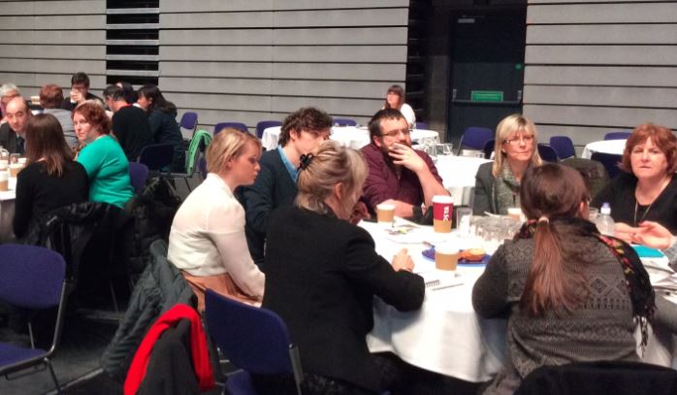

Themes from the panel discussion

Examining the links between homelessness and poor health and the case for advocating for affordable housing. Recognition of the need to influence housing policy to ensure everyone has a quality standard of accommodation.
Supporting people to be included in community planning and the partnership agenda, including building capacity, raising public awareness and bringing people together to tell our stories and acknowledge that there are alternatives.

Spreading good practice by promoting accessible and affordable ways to communicate the good work and good practice of collaborations.

Promoting collaboration and partnership, including statutory sector promoting the work of their third sector partners and potential cross-sector boundaries.

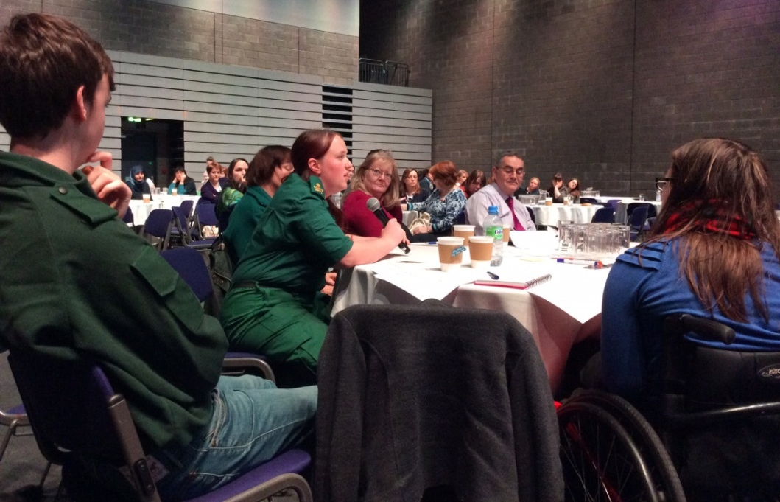

The final word

The session inspired lively discussion and the panel reflected on the following observations and themes that emerged throughout the session:

- Unequal societies are broken societies.
- We need to focus on strengthening community solidarity.
- Dignity should be at the heart of any framework to address health inequalities.
- People and communities should be connected to policy and planning.
- There should be a focus on supporting and advocating for policies that will make structural changes and support those in poverty.
- We need to use a variety of different types of evidence to make desirable changes and influence policy.
- Making sure the third sector uses levers of influence and power in the right way.

Partnership

Collaborative working to reduce health inequalities is already well underway. CHEX, CFHS, part of NHS Health Scotland, and Voluntary Health Scotland work in partnership on a programme of work to address health inequalities. Below is some of the work carried out by our organisations:

- CHEX supports localised community-led health networks and promotes training and capacity building primarily through ‘Health Issues in the Community’ and community development approaches to tackling health inequalities. www.chex.org.uk

- CFHS supports work with low income communities that improve access to, and uptake of, a healthy diet. Major obstacles being addressed by community-based initiatives are availability, affordability, skills and culture. www.communityfoodandhealth.org.uk/

- NHS Health Scotland provides improvement support for Community Planning Partnerships – including provision of evidence, data, outcome-focused planning and health inequality impact assessments. www.healthscotland.com/

- VHS works with voluntary health organisations and other sectors to promote, support and influence the health inequalities agenda. They champion the Engagement Matrix as a catalyst for health boards and voluntary sectors to collaborate. www.vhscotland.org.uk

